CFD ANALYSIS OF DOUBLE-DIFFUSIVE CONVECTIVE HEAT FLOW IN MHD BRAKING SYSTEM ATTACHED TO ROTATING BRAKE DISK: SORET AND DUFOUR EFFECTS
UPENDRA SINGH, SUBAS CHANDRA DASH , KEDARI LAL DHAKER
Mechanical Engineering Department,Jaypee University of Engineering and Technology,A_B Road Address, Guna, 473226, India
subas.dash@juet.ac.in, subasiitkgp@gmail.com
Received Day Month Year
Revised Day Month Year
The present research work, investigates Soret and Dufour effects in a double diffusion mixed convection rotating flow, due to the MHD braking effect both at positive and negative buoyancy ratio. The cylindrical annular shape MHD braking system is packed with liquid metal. Numerical simulations have been carried out when both the outer and inner discs are either electrically conducting or insulated, which is to say, at different electric potential boundary conditions.
The effect of Hartmann strength due to Dufour and Soret effects on rotating liquid metal has been investigated to determine the heat rate and mass concretion ratio within the braking system.
These phenomena are interpreted from average Nusselt and Sherwood numbers. Moreover, Duffer and Soret effects in MHD braking in the presence of Joules heating have been explored. In the presence of the positive as well as negative buoyancy ratio condition MHD braking systems are discussed in the presence of Dufour and Soret effect.
Keywords:Jules heating; MHD; swilling flow; Liquid metal.

Introduction
Double-diffusive convection is a conspicuous subject due to its widespread technical application such as in chemical processes, oceanography, geology, biology, astrophysics, [1]. Also, Double diffusion in a MHD flow system is an interesting topic. Its application can be seen in many engineering applications such as; MHD braking system, self-cooled liquid metal blankets in a fusion reactor, geothermal source studies, plasma, MHD power generator [2], electronics cooling [3,4], heat exchangers[5].So many research has been conducted to investigate the nature of the confined rotating flow, [Lopez 6] ,Shtern and Hussain [7], JØrgensen et al. [8] , Dash and Sigh [2018, 9], The rotating flow has been analysied in the absence of The effect of MHD rotating flow along with axial temperature gradient has been discussed by Lee and Hyun [10, 1999], Iwatsu[11], Dash and Sigh [12], Dash and Sigh[13] In the presence of only axial magnetic field the confined rotaing flow has been observer by Bessaih et al.[14,15, 1999, 2003], Gelfgat and Gelfgat [ 16, 2004]. In case of combined effect of axial temperature gradient as well as axial Magnetic field has been investigated by Dash and Sigh [2011, 17], Chatterjee et al. [2013.18], Dash [2015,19], Dash and Singh[2019 a, 2019b, 20,21], Mahfoud, and Bessaïh [2012a, 2012b, 22,23]. The effect of Joules heating in MHD braking system has been discussed in Dash[24,25]
In Heat exchangers, nuclear power plants, electronic cooling systems, solar collectors, and other engineering and industrial applications mixed convection heat transfer a common phenomenon. The double-diffusive lid drive cavity flow has been studied by many researchers due to its widespread consideration in recent years [26-30]. The Double-Diffusive Mixed Convection flow in the presence of Joules heating with Soret number in an enclosed square cavity has been investigated by Satheesh and colleagues. [30, 2021]. Similar kind of invention has been conducted by Ghaffarpasand [31, 2018] with Soret as well as Dufour effects. Investigations have been directed at visualizing double-diffusive convection in a solar pond characterized by a salinity gradient, while factoring in the impacts of the Soret and Dufour effects by Li N et al. [32, 2022]. Observations show that the Soret effect aids in the distribution of temperature and concentration. However, it is affected by the Dufour effect, which reduces its significance. Investigations carried out by Mallikarjuna et al. [33, 2014], Bilal et al. [34, 2016], Gajjela et al. [35, 2017], Aly and El-Sapa [36, 2022], and Alomari et al. [37, 2023] focused on the phenomena of double diffusion in rotating cylindrical cavity flows while considering various control volume scenarios.In a recent study, Dash [2024,38] has examined the impact of the Soret effect on the double diffusion rotating flow in a cylindrical annulus MHD braking system packed with liquid metal.

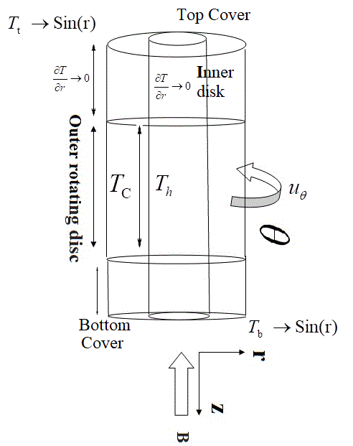
Fig 1: Schematic diagram of MHD Braking disk swirling flow with aspect ratio H/R, under the influence of axial magnetic field and axial temperature gradient.

2.0 Numerical Technique and Solution Procedure: In the present study, we considered a cylindrical annulus cavity packed with incompressible, viscous, metallic fluid having Prandtl number 0.015 under the influence of axial magnetic field and axial temperature gradient. The top and bottom cover, outer rotating disk and inner stationary disk surface of the cylindrical barking system are electrically as well as thermally conducting material; whereas the rest portion of outer cylinder of the cavity is insulated. Due to the presence electrical conducting wall, in the present numerical simulation Joule heating effect is considered.

2.1 Governing Equations: The fluid properties except density remain constant throughout the study. The density is calculated from Boussinesq approximation as given in the following Eq. (1) and (2).

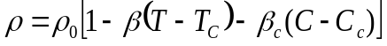 (1)

Where: 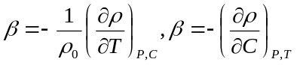 (2)

After entreating Boussinesq approximation in the governing equation and combining the Soret and Joule’s heating parameters in the absence of viscous dissipation, the of non-dimensional equations (Eqs. 3–7) are obtained.

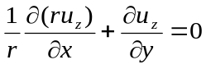 (3)
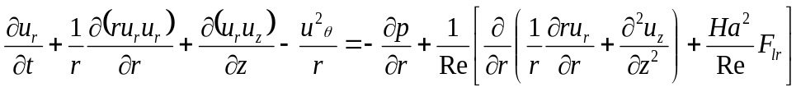 (4)
Momentum Equation in axial direction:
(5)
Momentum Equation in azimuthal direction:
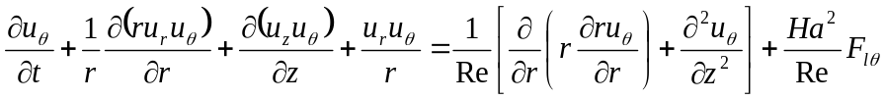 (6)
Energy Equation:
(7)
Concentration: (8)
Equation for Magnetic Flux:
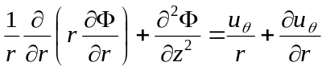 (9)
Where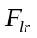, and are the Lorentz forces in radial, axial and azimuthal directions respectively and given:
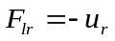(10-a), 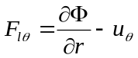 (10-b), 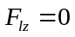(10-c)

2.2 Boundary Condition for Velocity field, Temperature, Mass concretion and electro-potential:
On outer surface of inner vertical Brake Disk:
Top Portion: 11-(a)
11-(b)
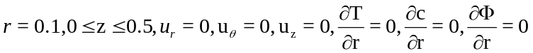 11-(c)
On inner surface of outer vertical Brake disk:
12-(a)
12-(b)
12-(c)
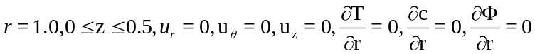 12-(d)
On the bottom Cover:
(13)
On the Top Cover:
(14)

(12) (15)
(14) (16)

The Solution Procedure: Chorin [39] and Peyter and Taylor [40] have detailed papers on the use of a modified MAC method for the solution of the incompressible Navier-Stoke equation in the present numerical simulation. The details of convergence criteria are discussed in my previous publications, Dash and Singh [23], Dash and Singh [29].The procedure of solving the radial and axial momentum equations in meridional plane (i.e. Plane) is based on pressure correction technique. The solution from the nth time level to the (n+1) time level is explicitly resolved, which allows for the generation of a velocity field that may or may not meet the continuity equation.
This problem is resolved by using pressure correction technique where the pressure and velocity components for each cell are corrected iteratively in such a way that for the final pressure field the velocity divergence in each cell vanishes.

Convergence Criteria: The iterative process continues until the velocity divergence for each cell is below the prescribed upper limit, which is 0.000001 for the present study.
The Steps are:
- The momentum equations are solved following the pressure correction technique described above.
- Subsequently, Temperature T and concretion field C are obtained by the explicit finite difference solutions of energy equation 7 and mass concentration equation 8 depending on the situation. The effects of temperature and contraction gradient in axial direct are experienced.
- The finite difference solution of equation 9 has been obtained using relaxation techniques to determine the electric potential when an axial magnetic field is applied. Equation 7 is used to calculate the Lorenz force components.
- Step (1) and step (3) are repeated until convergence for the case where the steady state exits or for a required time for unsteady flow calculations.

3.0 Results and Discussion: The radial component velocity of present result has been well matched with [Mahfoud and Bessaih, 2012a, 17] at Re = 900, Ri= 1, Ha= 5, Pr =0.015 and AR =2.0 as shown in Fig 2(b).
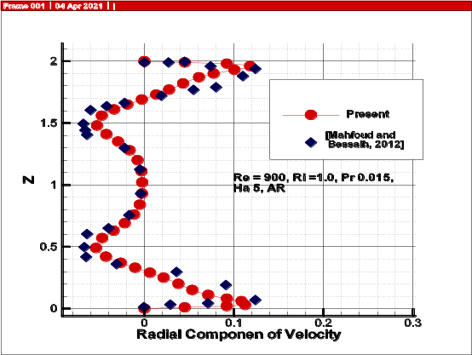
Fig 2(b): At Re = 900, Ri= 1, Ha= 5, Pr =0.015, Sr = 0, Sc = 0 and AR =2.0
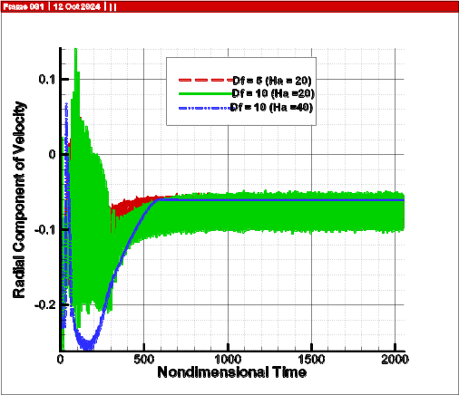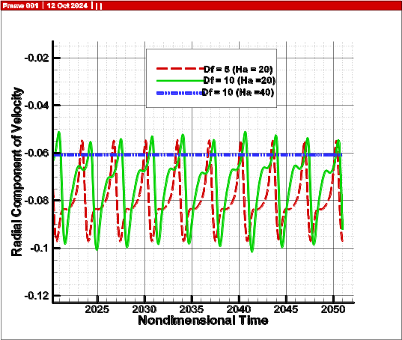
Fig3: Time history of Radial component of velocities for different Dufour number (Df), at Re = 1000, Ri =1.0, Pr =0.015, Sc=5, Sr= 0.25, Ha = 20 and 40.
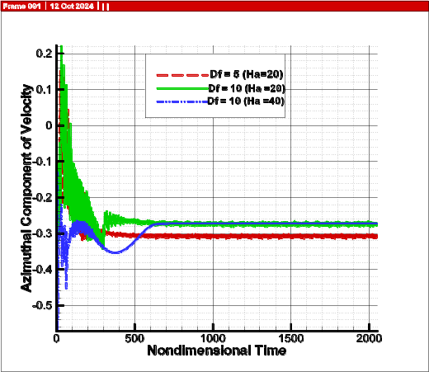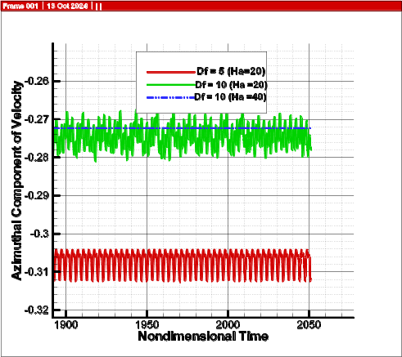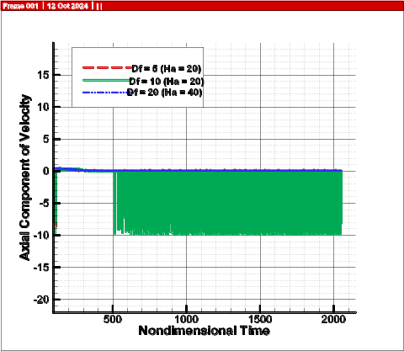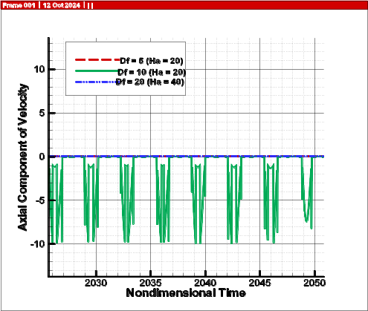
Fig3: Time history of Azimuthal and Axial component of velocities for different Dufour number (Df), at Re = 1000, Ri =1.0, Pr =0.015, Sc=5, Sr= 0.25, Ha = 20 and 40.

Due to the presence of Dufour effect, the flow within the MHD braking system becomes more unsteady which can be interpreted from radial, axial and Azimuthal velocity variation with respect to time. Moreover, at Re = 1000, Ri = 1.0, and Pr = 0.015 in the presence of a positive buoyancy ratio, the MHD braking system experiences steady flow at a Hartmann strength of Ha = 40, but it is unable to generate the braking effect. Based on the velocity gradient observations in the axial and radial profiles, it can be concluded that the MHD braking effect cannot occur in the flow at (Ha = 40) Fig 4. As depicted in Fig 4(a) and Fig 4(b), the velocity profiles indicate a notable difference in velocity magnitude throughout the axial direction.
The azimuthal velocity contours show the variation in Azimuthal velocity along axial direction Fig 5. In the presence of strong magnetic field, the fluid almost arrested within the MHD braking system packed with electrically conducting liquid which can be confirmed from both the contour plots and quantitative results of velocity profiles shown in Fig 5 and Fig 6 at Ha =100, 200 and 250. In the presence of strong magnetic field, the fluid almost arrested within the MHD braking system packed with electrical conducting liquid which can be confirmed from both the contour plots and quantitative results of velocity profiles shown in Fig 5 and Fig 6 at Ha =100, 200 and 250.

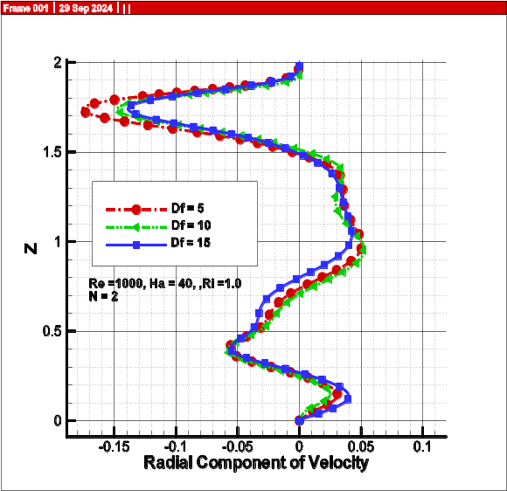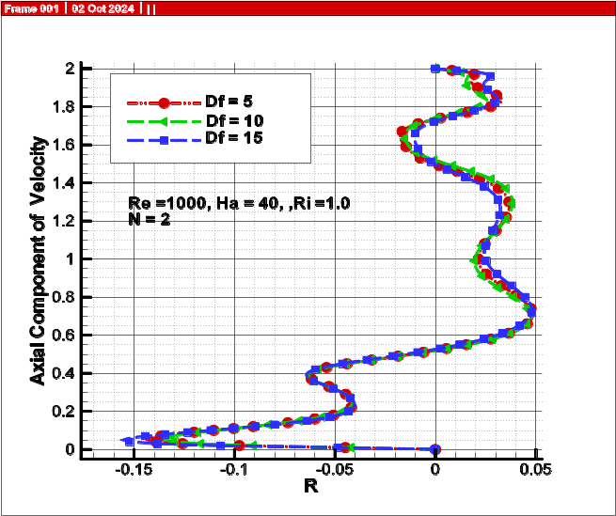
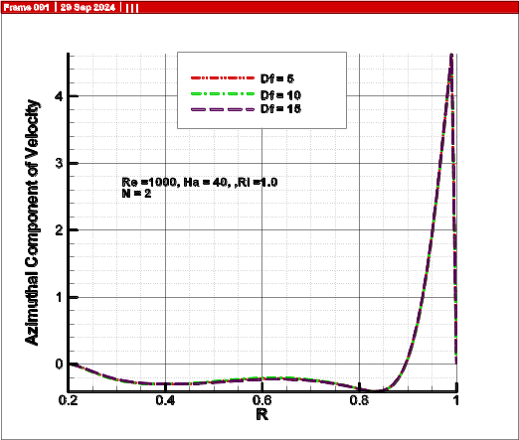
Fig4: At Re = 1000, Ri =1.0, Pr =0.015, Sc=5, Sr= 0.25,Ha =40, (a) axial profile of radial component of velocity (b) axial profile of axial component velocity and (c) Radial profiles Azimuthal component of velocity

The azimuthal velocity contours shows the variation in Azimuthal velocity along axial direction Fig 5. In the presence of strong magnetic field, the fluid almost arrested within the MHD braking system packed with electrical conducting liquid which can be confirmed from both the contour plots and quantitative results of velocity profiles shown in Fig 5 and Fig 6 at Ha =100, 200 and 250.
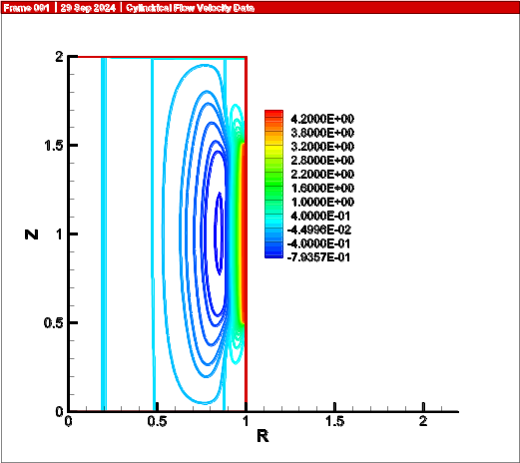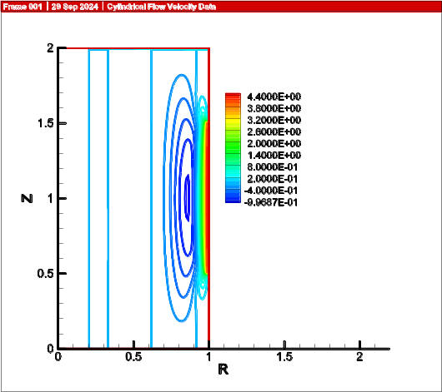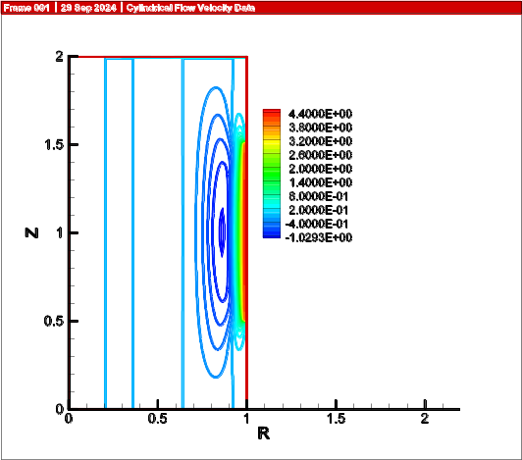
- (b) (c)
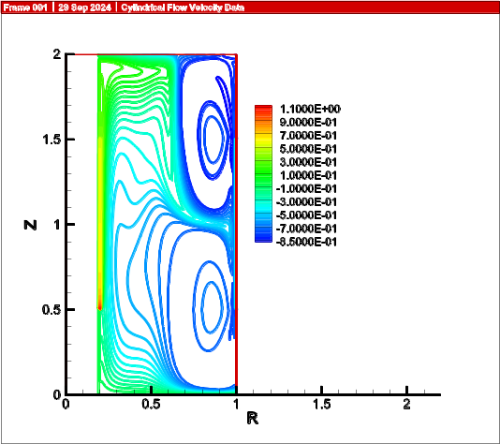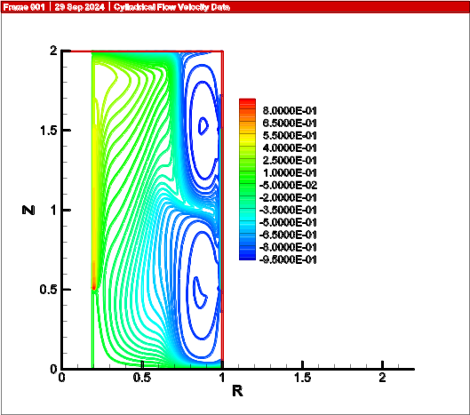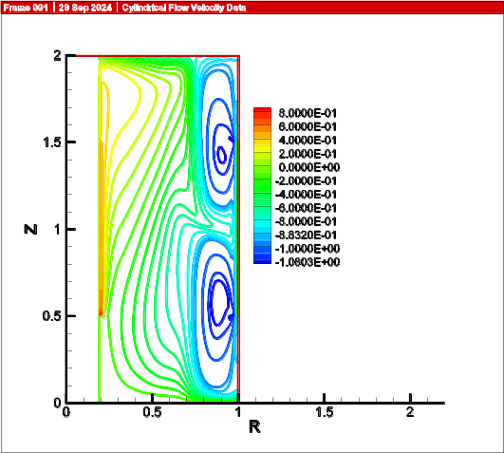
(d) (e) (f)
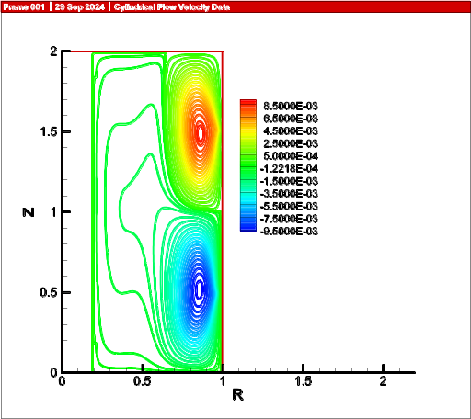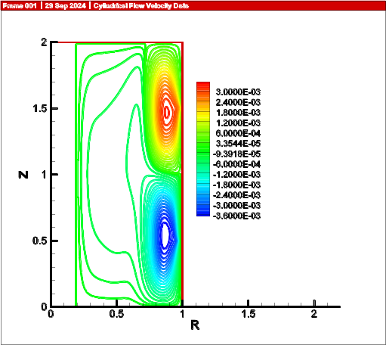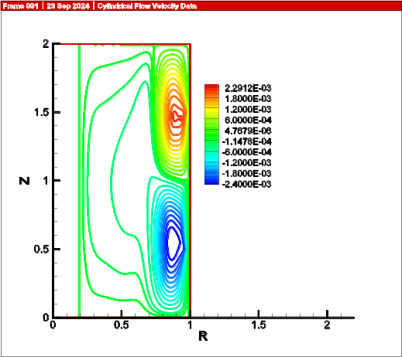
(g) (h) (i)
Fig 5: Contours of Azimuthal component of velocity, mass concentration contours and stream function at Re = 1000, Ri =1.0, Pr =0.015, Sc=5, Sr= 0.25, Ha =100,200 and 250
Fig 5 (a), (b) and (c) shows the Azimuthal velocity contours at different Hartmann strength Ha =100, 200 and 250 respectively; which indicate how the gyratory velocity induced by rotating disk has been suppressed only vicinity to rotating brake disk. However, the fluid flow has been arrested within the remaining utmost space of the MHD brake system due to the presence of strong Magnetic field. It can be further inferred that the rotating bake disc force can propagates insignificantly in the presence of the strong magnetic field. This behavior can be interpreted from mass concretion in Fig 5 (d), (e) and (f) and form of streamlined contours Fig 5(g), 5(h) and 5(i). At elevated Dufour levels (Df = 20), the fluctuations in velocity gradients have been reduced in the presence of a strong magnetic field, as depicted in Fig 6 which confirms the MHD braking.
In order to analysis the heat and mass concentration rate within the MHD braking system, the magnitude of average Nusselt number and Sherwood number has been evaluated near the inner disc and outer rotating disk. Fig 7(a) shows that with the Dufour (DF) effect on Nusselt number (Nu); which indicates that at Ha =100 the heat rate decreases initial (DF =0 to DF=8) and increases extensively from DF =8 to 20. However, with increase in Hartmann strength, i.e. at Ha= 150, 200, 250 the impact of Dufour effect decreases drastically and the curve trend almost similar to Ha = 100.

(a)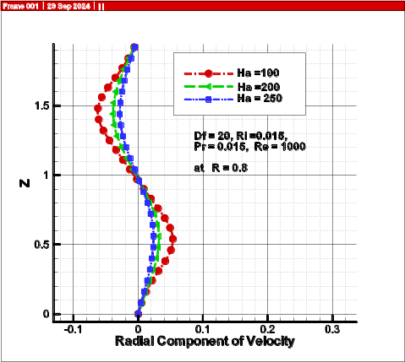(b)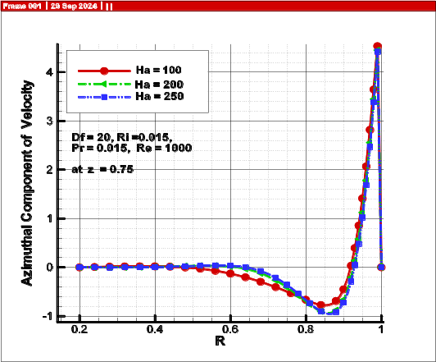 (c)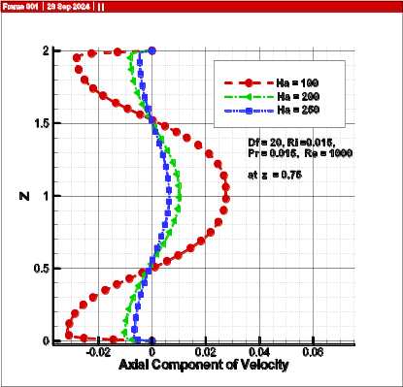
Fig 6: (a) Radial Component of velocity (b) Azimuthal Component of velocity (c) Axial Component of velocity: at Re = 1000, Ri =1.0, Pr =0.015, Sc=5, Sr= 0.25, Ha =100,200 and 250

The mass concentration ratio (Sherwood number), near the inner brake disk flow the similar tendency to heat transfer rate as shown in Figure 7(b). Moreover, Sherwood magnitude at Ha =100 decreases from Df =0 to Df =7, increases onwards and reaches maximum magnitude at Df =20. In the presence of strong magnetic field, at Ha = 150, 200 and 250 the mass convection decreases significantly that induced due to Dufour effect in the presence of positive buoyancy ratio. The strong magnetic field brakes flow of electrical conducting fluid which instability induced by Dufour effect within the braking system. Hence, both mass and heat convection reduces.

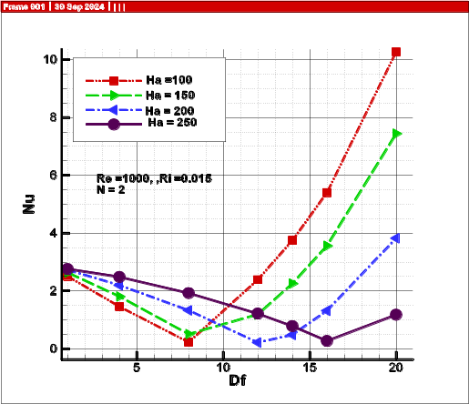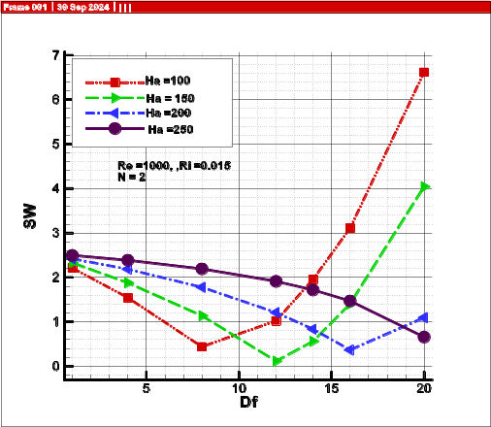
Fig7. (a) Variation of average Nusselt number with increase in Dufour Number (b) Average Variation of average Sherwood number with increase in Dufour Number : Vicinity to inner rotating disk, Re = 1000, Ri =1.0, Pr =0.015, Sc=5, Sr= 0.25, Ha =100,200 and 250 for positive buoyancy ratio (N= 2).
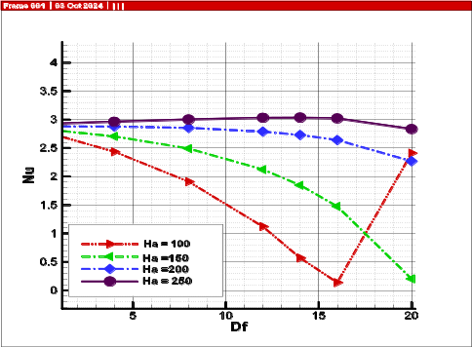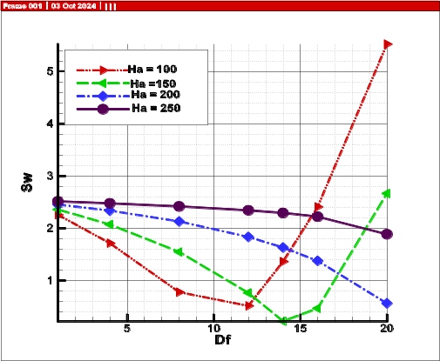
Fig 8. (a) Variation of average Nusselt number with increase in Dufour Number (b) Average Variation of average Sherwood number with increase in Dufour Number : Vicinity to inner rotating disk, Re = 1000, Ri =1.0, Pr =0.015, Sc=5, Sr= 0.25, Ha =100,200 and 250 for negative buoyancy ratio (N= -2).

In the presence of negative buoyancy ratio (N=-2), the variations in Nusselt number i.e. fluctuations in convective heat transfer is minimized in the presence of strong magnetic (Ha =250) field with increase in Dufour effect shown in Fig 8(a). Since, Dufour effect coupled heat rate with mass concentration, it creates instability both in heat and mass flow rate. At Ha =100, the heat flow rate initially is showing a reducing pattern (Df =1 to Df = 15) which is similar both at negative and positive buoyancy ratio. The Sherwood magnitude decreases drastically. It is evident that both the Nusselt number (Nu) and Sherwood number (SW) at the inner disk (Fig-8 and b) are significantly diminished in contrast to the outer rotating disk (Fig-9 a and b).
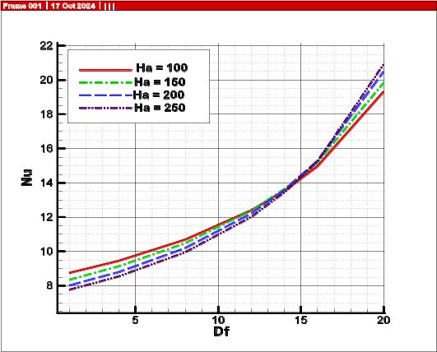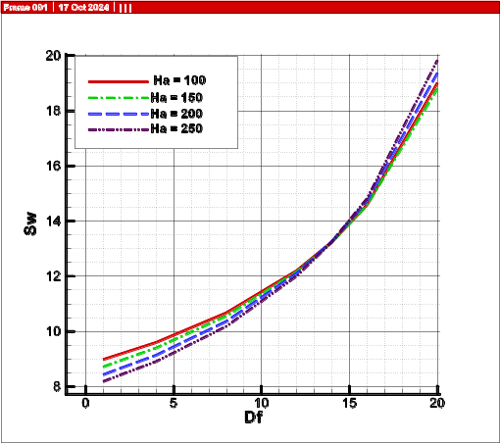
Fig 9. (a) Variation of average Nusselt number with increase in Dufour Number (b) Variation of average Sherwood number with increase in Dufour Number : Vicinity to outer rotating disk, Re = 1000, Ri =1.0, Pr =0.015, Sc=5, Sr= 0.25, Ha =100,200 and 250 for negative buoyancy ratio (N= -2).
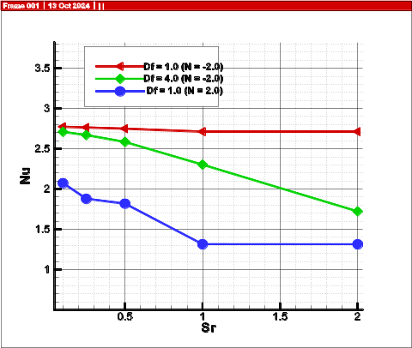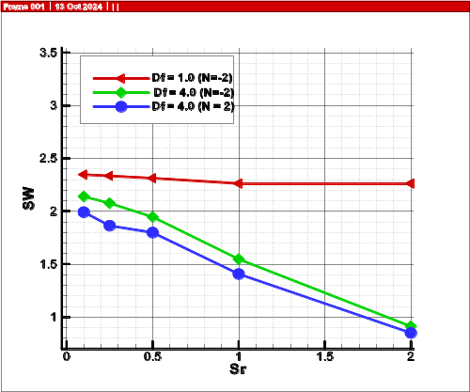
Fig 10. Soret and Dufour effect due to positive and negative buoyancy ratio on (a) Average Nusselt number (b) Average Sherwood number: At inner rotating disk, Re = 1000, Ri =1.0, Pr =0.015, Sc=5, Ha =100,200 and 250 (vicinity to inner bake disc )

In the presence of negative buoyancy ratio (N=-2), the variations in Nusselt number i.e. fluctuations in convective heat transfer is minimized in the presence of strong magnetic (Ha =250) field with increase in Dufour effect shown in Fig 8(a). Since, Dufour effect coupled heat rate with mass concentration, it creates instability both in heat and mass flow rate. At Ha =100, the heat flow rate initially is showing a reducing pattern (Df =1 to Df = 15) which is similar both at negative and positive buoyancy ratio. The Sherwood magnitude decreases drastically. It is evident that both the Nusselt number (Nu) and Sherwood number (SW) at the inner disk (Fig-8 and b) are significantly diminished in contrast to the outer rotating disk (Fig-9 a and b).
The consequence of Dufour effect with increase in Soret effect in the presence of strong magnetic field (Ha =100) both at positive and negative buoyancy ratio has been investigated. It has been visualized that at higher Dufour effect the increasing Soret effect decreases both convective heat and mass transfer near the inner disk of braking system in the presence of negative buoyancy ratio. Further, this mass and heat convection reduces at positive buoyancy ratio in comparison to negative buoyancy ratio, shown in Fig 10(a) and (b). However, near rotating disk, both at positive and negative buoyancy ratio, the convective mass and heat transfer increases with increase in Soret effect at in the presence of growing Dufour effects, Fig 11(a) and (b).

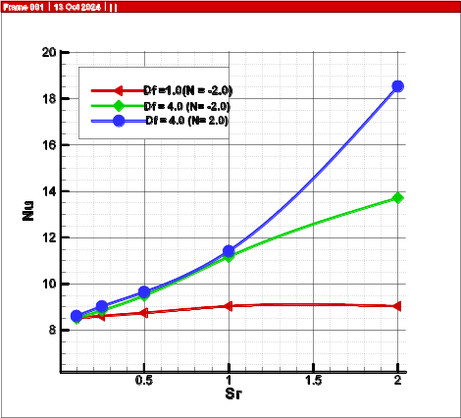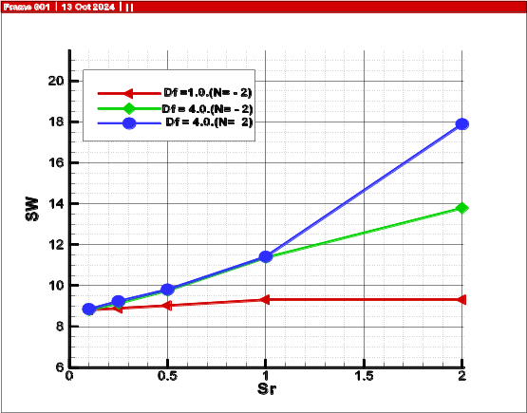
Fig 11. Soret and Dufour effect due to positive and negative buoyancy ratio on (a) Average Nusselt number (b) Average Sherwood number: At inner rotating disk, Re = 1000, Ri =1.0, Pr =0.015, Sc=5, Ha =100,200 and 250 (vicinity to outer bake disc )

4.0 Conclusion: In this present study, the combined effects of Sorert and Dufour effects are investigated on rotating flow of liquid metal within a MHD braking system. The fluid flow has been arrested within the remaining utmost space of the MHD brake system due to the presence of strong Magnetic field. It can be further inferred that the rotating bake disc force can propagate insignificance in the presence of the strong magnetic field. The Dufour effect enhances both heat and mass convection near rotating and stationary disk of the braking system up to Ha =100. However, in the presence of stronger magnetic the Dufour effects have been detained significantly within the MHD braking system. The increasing Dufour effect in parallel to the escalating Soret effect decreases both convective heat and mass transfer near the inner disk of braking system in the presence of negative buoyancy ratio near the inner stationary disk of braking system. However, near the rotating disk, both positive and negative buoyancy ratios show that the convective transfer of heat and mass increases as the Soret effect intensifies, particularly under the growing influence of Dufour effects

References:
- Schmitt, Raymond W. "Double diffusion in oceanography." Annual review of fluid mechanics 26, no. 1 (1994): 255-285.
- El-Kabeir, S. M. M., M. Modather, and M. Abdou. "Chemical reaction, heat and mass transfer on MHD flow over a vertical isothermal cone surface in micropolar fluids with heat generation/absorption." Applied Mathematical Sciences 1, no. 34 (2007): 1663-1674.
- Hooman, K., and H. Gurgenci. "Porous medium modeling of air-cooled condensers." Transport in Porous Media 84 (2010): 257-273.
- Banerjee, Sumanta, Achintya Mukhopadhyay, Swarnendu Sen, and Ranjan Ganguly. "Natural convection in a bi-heater configuration of passive electronic cooling." International Journal of Thermal Sciences 47, no. 11 (2008): 1516-1527.
- Boulemtafes-Boukadoum, A., Cherifa Abid, and A. Benzaoui. "3D Numerical study of the effect of aspect ratio on mixed convection air flow in upward solar air heater." International Journal of Heat and Fluid Flow 84 (2020): 108570.
- Lopez, JM1148249. "Axisymmetric vortex breakdown Part 1. Confined swirling flow." Journal of Fluid Mechanics 221 (1990): 533-552.
- Shtern, Vladimir, and Fazle Hussain. "Hysteresis in swirling jets." Journal of Fluid Mechanics 309 (1996): 1-44.
- Jørgensen, Bo Hoffmann, Jens Nørkær Sørensen, and Nadine Aubry. "Control of vortex breakdown in a closed cylinder with a rotating lid." Theoretical and Computational Fluid Dynamics 24 (2010): 483-496.
- Dash, Subas Ch, and Navtej Singh. "Stability boundaries for vortex breakdowns and boundaries between oscillatory and steady swirling flow in a cylindrical annulus with a top rotating lid." Journal of the Brazilian Society of Mechanical Sciences and Engineering 40, no. 7 (2018): 336.
- Lee, Chang Ho, and Jae Min Hyun. "Flow of a stratified fluid in a cylinder with a rotating lid." International journal of heat and fluid flow 20, no. 1 (1999): 26-33.
- Iwatsu, Reima. "Flow pattern and heat transfer of swirling flows in cylindrical container with rotating top and stable temperature gradient." International journal of heat and mass transfer 47, no. 12-13 (2004): 2755-2767.
- Dash, S., and N. Singh. "Effects of partial heating of top rotating lid with axial temperature gradient on vortex breakdown in case of axisymmetric stratified lid driven swirling flow." Yildiz Technical University Press, Istanbul, Turkey, J. Thermal Eng 2 (2016): 883-896.
- Dash, Subas Chandra. "Study of axisymmetric nature in 3-d swirling flow in a cylindrical annulus with a top rotating lid under the influence of axial temperature gradient or axial magnetic field." Journal of Thermal Engineering 3, no. 6 (2017): 1588-1606.
- Bessaih, R., Ph Marty, and M. Kadja. "Numerical study of disk driven rotating MHD flow of a liquid metal in a cylindrical enclosure." Acta Mechanica 135 (1999): 153-167.
- Bessaïh, Rachid, Mahfoud Kadja, Kerstin Eckert, and Philippe Marty. "Numerical and analytical study of rotating flow in an enclosed cylinder under an axial magnetic field." Acta mechanica 164 (2003): 175-188.
- Gelfgat, Yu M., and A. Yu Gelfgat. "Experimental and numerical study of rotating magnetic field driven flow in cylindrical enclosures with different aspect ratios." Magnetohydrodynamics 40, no. 2 (2004): 147-160.
- Dash, Subas, and Navtej Singh. "Analysis of axisymmetric lid driven swirling flow under magnetic field with an axial thin rod." In ASME, applied mechanics and materials conference, MacMat. 2011.
- Chatterjee, Dipankar, Pabitra Halder, Sinchan Mondal, and Supratim Bhattacharjee. "Magnetoconvective transport in a vertical lid-driven cavity including a heat conducting square cylinder with Joule heating." Numerical Heat Transfer, Part A: Applications 64, no. 12 (2013): 1050-1071.
- Dash, Subas Chandra. "Incompressible confined swirling flow in a cylindrical cavity with rotating lid under the influence of axial temperature gradient or axial magnetic field." PhD diss., IIT, Kharagpur, 2015.
- Dash, Subas Chandra, and Navtej Singh. "Effect of a strong axial magnetic field on swirling flow in a cylindrical cavity with a top rotating lid." International Journal of Modern Physics C 30, no. 11 (2019): 1950092.
- Dash, Subas Chandra, and Navtej Singh. "Influence of axial magnetic field on swirling flow and vortex breakdown zones in a cylindrical cavity with a rotating lid." International Journal of Applied Mechanics 11, no. 06 (2019): 1950054.
- Mahfoud, Brahim, and Rachid Bessaïh. "Stability of swirling flows with heat transfer in a cylindrical enclosure with co/counter-rotating end disks under an axial magnetic field." Numerical Heat Transfer, Part A: Applications 61, no. 6 (2012): 463-482.
- Mahfoud, Brahim, and Rachid Bessaih. "Oscillatory swirling flows in a cylindrical enclosure with co-/counter-rotating end disks submitted to a vertical temperature gradient." Fluid Dynamics & Materials Processing 8, no. 1 (2012): 1-26.
- Dash, Subas Ch. "MHD braking and joules heating effect in a rotating confined cylindrical cavity packed with liquid metal." FME Transactions 49, no. 2 (2021): 437-444
- Dash, Chandra Subas. "CFD analysis of Joule heating effect in a confined axi-symmetric swilling flow under the influence of axial magnetic field." International Journal of Computational Materials Science and Engineering 10, no. 03 (2021): 2150010.
- Hadavand, Masoud, Shahrouz Yousefzadeh, Omid Ali Akbari, Farzad Pourfattah, Hoang Minh Nguyen, and Amin Asadi. "A numerical investigation on the effects of mixed convection of Ag-water nanofluid inside a sim-circular lid-driven cavity on the temperature of an electronic silicon chip." Applied Thermal Engineering 162 (2019): 114298.
- Shin, Dong-Ho, Chan Soo Kim, Goon-Cherl Park, and Hyoung Kyu Cho. "Experimental analysis on mixed convection in reactor cavity cooling system of HTGR for hydrogen production." International Journal of hydrogen energy 42, no. 34 (2017): 22046-22053.
- Shin, Dong-Ho, Chan Soo Kim, Goon-Cherl Park, and Hyoung Kyu Cho. "Experimental analysis on mixed convection in reactor cavity cooling system of HTGR for hydrogen production." International Journal of hydrogen energy 42, no. 34 (2017): 22046-22053.
- Tassone, Alessandro, Gianfranco Caruso, Fabio Giannetti, and Alessandro Del Nevo. "MHD mixed convection flow in the WCLL: Heat transfer analysis and cooling system optimization." Fusion Engineering and Design 146 (2019): 809-813.
- Satheesh, A., C. G. Mohan, P. Padmanathan, and Agarwal Anmol Pallav Kumar. "Effects of Joules Heating and Soret Number on Double-Diffusive Mixed Convection Flow in an Enclosed Square Cavity." In Proceedings of International Conference on Thermofluids: KIIT Thermo 2020, pp. 209-223. Springer Singapore, 2021.
- Ghaffarpasand, Omid. "Characterization of unsteady double-diffusive mixed convection flow with soret and dufour effects in a square enclosure with top moving lid." Journal of Heat and Mass Transfer Research 5, no. 1 (2018): 51-68.
- Li, Nan, Pan Gao, and Caihong Zhang. "Soret and Dufour effects on double-diffusive convection in a salinity gradient solar pond." Solar Energy 246 (2022): 66-73.
- Mallikarjuna, B., Ali J. Chamkha, and R. Bhuvana Vijaya. "Soret and Dufour effects on double diffusive convective flowthrough a non-darcy porous medium in a cylindrical annular region in the presence of heat sources." Journal of Porous Media 17, no. 7 (2014).
- Bilal, S., Khalil Ur Rehman, Hamayun Jamil, M. Y. Malik, and T. Salahuddin. "Dissipative slip flow along heat and mass transfer over a vertically rotating cone by way of chemical reaction with Dufour and Soret effects." AIP Advances 6, no. 12 (2016).
- Gajjela, Nagaraju, Anjanna Matta, and K. Kaladhar. "The effects of Soret and Dufour, chemical reaction, Hall and ion currents on magnetized micropolar flow through co-rotating cylinders." AIP Advances 7, no. 11 (2017).
- Aly, Abdelraheem M., and Shreen El-Sapa. "Effects of Soret and Dufour numbers on MHD thermosolutal convection of a nanofluid in a finned cavity including rotating circular cylinder and cross shapes." International Communications in Heat and Mass Transfer 130 (2022): 105819.
- Alomari, Mohammed Azeez, Khaled Al-Farhany, Nejla Mahjoub Said, and Mujtaba A. Flayyih. "Numerical investigation of double-diffusive mixed convection in a split lid-driven curvilinear cavity." International Communications in Heat and Mass Transfer 138 (2022): 106322.
- Dash, Subas Chandra. "Effects of double diffusion and soret effect on mhd braking of liquid metal packed between enclosed rotating cylindrical annulus." International Journal of Modern Physics C (2024).
- Chorin, Alexandre Joel. "A numerical method for solving incompressible viscous flow problems." Journal of computational physics 135, no. 2 (1997): 118-125.
- Peyret, Roger, and Thomas D. Taylor. Computational methods for fluid flow. Springer Science & Business Media, 2012.
- Mohan, Pudari Chandra, Anjanna Matta, and Y. Suresh Kumar. "The effect of soret and mass flow in a double-diffusive analysis of Maxwell fluid flow through a horizontal porous layer." In AIP Conference Proceedings, vol. 3160, no. 1. AIP Publishing, 2024.

For the title, try not to use more than 3 lines. Typeset the title in 10 pt Times Roman, uppercase and boldface.
Typeset names in 8 pt Times Roman, uppercase. Use the footnote to indicate the present or permanent address of the author.
State completely without abbreviations, the affiliation and mailing address, including country. Typeset in 8 pt Times Italic.

